Dear Parents/Guardians:

Today, the students had an opportunity to participate in planting a native plant meadow in the boulevard on Treanor Avenue. This bee and biodiversity boosting project is the result of a collaboration between Millstream School, SD62, Millstream PAC, City of Langford, Satinflower Nurseries, Garden City Landscaping and Habitat Conservation Trust Foundation.

The students did a fantastic job planting today! After learning about the project from Wild Schools’ Facilitator Michelle Paleczny, they walked over to the boulevard and planted a native plant. Huge thanks to everyone who made today’s initiative a memorable success. I especially want to recognize Michelle Paleczny’s vision as well as Mr. Deichmann’s assistance from the school garden. Well done, Millstream Team!

If you're interested in being involved in ongoing care of the meadow, please email [mcpaleczny@gmail.com](mailto:mcpaleczny@gmail.com). Thank you!

**Halloween 2022**

Monday, October 31st is a Spirit Day when students are encouraged to wear orange & black or their Halloween costume. If your child(ren) is wearing a costume, please ensure that they follow the guidelines below.

**District Halloween Costume Guidelines letter**

**School Supplies**

If you still need school supplies for your child/ren, please contact the office and we can assist.

**We Remember:**

At this year's Remembrance Day Assembly, we would like to take a moment to honor parents and family members who are serving or have served. Please send a photo with the following information:

- Name of person we are remembering

- Relation to and name of student

- Years served (if available)

Please send in to one of the following emails by Nov. 4th.

[jbelangerborysiak@sd62.bc.ca](mailto:jbelangerborysiak@sd62.bc.ca)

[nwhitling@sd62.bc.ca](mailto:nwhitling@sd62.bc.ca)

**PAC NEWS**

Greetings Millstream Families

I hope you are enjoying the nice weather this fall and watching our children get familiar with the Fall school routines.

**SAVE THE DATE - NOVEMBER PAC MEETING**

 Nov 8th 7:30pm (online and in person at the Millstream Library)

[https://teams.microsoft.com/l/meetup-join/19%3ameeting_NWNhOTJmYjUtMDRkZS00YmRmLTg4OTMtYWJmZjRhMjg5NzIz%40thread.v2/0?context=%7b%22Tid%22%3a%22f7c5b01f-413e-4ee8-9788-ce578108cd30%22%2c%22Oid%22%3a%2292809954-66e3-451f-b0c0-a34afc2d62e0%22%7d](https://urldefense.com/v3/__https:/teams.microsoft.com/l/meetup-join/19*3ameeting_NWNhOTJmYjUtMDRkZS00YmRmLTg4OTMtYWJmZjRhMjg5NzIz*40thread.v2/0?context=*7b*22Tid*22*3a*22f7c5b01f-413e-4ee8-9788-ce578108cd30*22*2c*22Oid*22*3a*2292809954-66e3-451f-b0c0-a34afc2d62e0*22*7d__;JSUlJSUlJSUlJSUlJSUl!!AqQTiOZlHyw!73mVFT_5xJublpVnMPuwpNoMqiTVmLX1m-vp6epuHQje0HKsPC_oOxtdEl7DtnH9yPQQalXC6Pbsovlm7O_z$)

Stay tuned for the Agenda here or on the Facebook Group.

To view last month's meeting, click here:

[Millstream PAC meeting-20221011_193247-Meeting Recording.mp4](https://urldefense.com/v3/__https:/sooke62-my.sharepoint.com/:v:/g/personal/pac-millstream_sd62_bc_ca/Eb1hpkPSjNFMhZjhViFlsH0BPk0vr9JuE_erg5v7whlxaw?e=EfqxxL__;!!AqQTiOZlHyw!73mVFT_5xJublpVnMPuwpNoMqiTVmLX1m-vp6epuHQje0HKsPC_oOxtdEl7DtnH9yPQQalXC6PbsorOynryO$)

Password: MillstreamPAC22

**FUNDRAISING EVENTS**

Millstream PAC members are putting together this year's 2022 Winter Market Craft Fair! Saturday December 3, 2022 approx. 10-3pm.

We would like to give the families and employees at the school first dibs on the tables ($30.00) prior to offering outside of the school.

If you can please email [Jana_Dunnett@outlook.com](mailto:Jana_Dunnett@outlook.com) to let us know if you are interested in a table prior to the end of the day Monday October 24 2022 (please include your relation to the school in your email).

Please email Angela for details [angelamorehouse21@gmail.com](mailto:angelamorehouse21@gmail.com)

**Purdy’s Chocolates**

Want to know the most ***delicious*** way to support us? Order Purdy’s chocolates from our fundraiser!

This year, we’re hoping to raise $1,000 for Millstream School.

From now until November 28th, you can order Purdy’s treats from our fundraiser by joining our campaign and browsing the tastiest selection of chocolates online. Shop gifts for family, friends, neighbors ***and*** yourself in one convenient place. Chocolates will be available to pick up from the school December 12th under the breezeway after school.

What you’ll need to order:

1.      Our campaign number:57281

2.      Go to our fundraising website link:

[https://fundraising.purdys.com/join.aspx/1217634-98062?fbclid=IwAR0vfi27cBYtE0gRHUZUKX6AHPiZpi9FKkHknQAzMpSlCngGGCNRxlJ6TCc](https://urldefense.com/v3/__https:/fundraising.purdys.com/join.aspx/1217634-98062?fbclid=IwAR0vfi27cBYtE0gRHUZUKX6AHPiZpi9FKkHknQAzMpSlCngGGCNRxlJ6TCc__;!!AqQTiOZlHyw!7GYkB2ijWcWq3FIKd_z1XfaQB-rksQ8gY1I4Z56SjOqTA5Ea3gG3mXVGHTGehRq32YmpMLqXUED8mU5KcKQM3UxYysimDSs$)

3.      Click “Join Campaign”

4.      Shop, shop, shop away!

Thank you everyone for your support. Even if you can’t buy chocolates from us, it would mean the world if you could share this fundraiser link to everyone you know!

Happy chocolating!

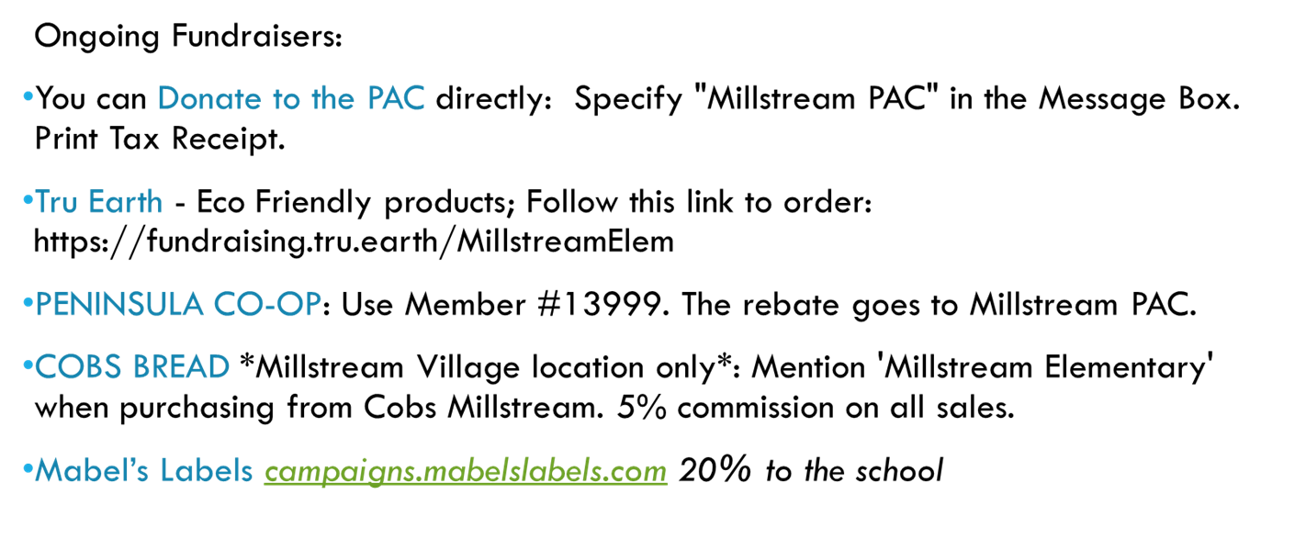

Thank you,

The Millstream Team