Dear Parents/Guardians:

**Frances write up**

**Great Shake Out Earthquake Drill**

On October 20th at 10:00am Millstream will be practicing an Earthquake drill. We live in an earthquake zone with a one in three chance for a damaging earthquake within the next 50 years. That quake could strike during school hours when you and your child are separated. Our goal is to develop a strong emergency preparedness culture at Millstream Elementary. Preparing our children is one of the most important tasks we can do.

**Photo Re-take day**

Thursday, November 3rd

**Drop off/Pick up**

**Some gentle reminders to help keep everyone safe at drop off/pick up…**

* **Stay in your vehicle** if you are in the drop off/pick up lane
* When in the drop off/pick up lane **pull up to the front of the school to let your child(ren) in/out of your car**
* **Use the cross walks** to cross Hoy Lake & Treanor Avenue
* Use the sidewalks around the school. **Do not cut through the parking lot at the front of the school**.

**PAC NEWS**

Millstream PAC members are putting together this year's 2022 Winter Market craft fair 😍!   
Saturday December 3 2022 approx. 10-3pm.

We would like to give the families and employees at the school first dibs on the tables ($30.00) prior to offering outside of the school.

If you can please email [Jana_Dunnett@outlook.com](mailto:Jana_Dunnett@outlook.com) to let us know if you are interested in a table prior to the end of the day Monday October 24 2022 (please include your relation to the school in your email).

Winter market planning committee meeting on Monday oct 17th.

Please email Angela for details [angelamorehouse21@gmail.com](mailto:angelamorehouse21@gmail.com)

Thank you in advance everyone!  
Millstream PAC

**Invite for boulevard planting volunteers**

All students will have an opportunity to participate in planting a native plant meadow in the boulevard in front of the school on **Wed Oct 26!** This bee and biodiversity boosting project is the result of a collaboration between Millstream School, SD62, Millstream PAC, City of Langford, Satinflower Nurseries, Garden City Landscaping and Habitat Conservation Trust Foundation. We'll have ongoing learning opportunities in the meadow as we watch seedlings sprout with the fall rain, plants establish over the first year, and provide care by removing weeds.

If you're interested in being involved in planting day and/or ongoing care, please email [mcpaleczny@gmail.com](mailto:mcpaleczny@gmail.com). Thank you!

Thanks,

Michelle

**Fundraisers**

Want to know the most DELICIOUS way to support us? Order Purdys chocolates from our fundraiser!

This year, we’re hoping to raise 1,000 for millstream school.

From now until November 28th, you can order Purdy’s treats from our fundraiser by joining our campaign and browsing the tastiest selection of chocolates online. Shop gifts for family, friends, neighbors AND yourself in one convenient place. Chocolates will be available to pick up from the school December 12th under the breezeway after school.

What you’ll need to order:

1.      Our campaign number:57281

2.      Go to our fundraising website link :

[https://fundraising.purdys.com/join.aspx/1217634-98062?fbclid=IwAR0vfi27cBYtE0gRHUZUKX6AHPiZpi9FKkHknQAzMpSlCngGGCNRxlJ6TCc](https://urldefense.com/v3/__https:/fundraising.purdys.com/join.aspx/1217634-98062?fbclid=IwAR0vfi27cBYtE0gRHUZUKX6AHPiZpi9FKkHknQAzMpSlCngGGCNRxlJ6TCc__;!!AqQTiOZlHyw!7GYkB2ijWcWq3FIKd_z1XfaQB-rksQ8gY1I4Z56SjOqTA5Ea3gG3mXVGHTGehRq32YmpMLqXUED8mU5KcKQM3UxYysimDSs$)

3.      Click “Join Campaign”

4.      Shop, shop, shop away!

Thank you EVERYONE for your support. Even if you can’t buy chocolates from us, it would mean the world if you could share this fundraiser link to everyone you know!

Happy chocolating!

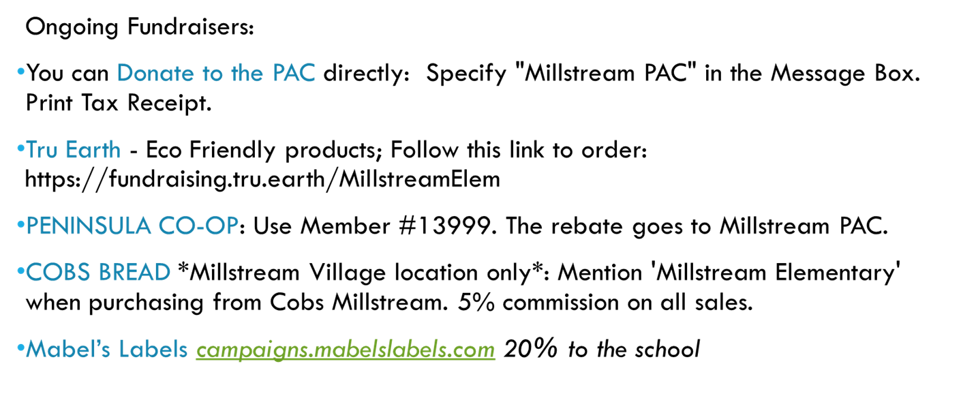

Thank you,

Ash Senini

PAC President

[millstreampac@gmail.com](mailto:millstreampac@gmail.com)

Thank you,

The Millstream Team